[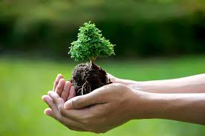](https://www.google.com/imgres?imgurl=http://www.bonsaitreegardener.net/wp-content/uploads/2015/04/bonsai-tree-care.jpg&imgrefurl=http://www.bonsaitreegardener.net/care&docid=oRxtrxuLDtLY6M&tbnid=4ab6WT3Lnn-5SM:&w=4256&h=2832&safe=strict&bih=673&biw=1280&ved=0ahUKEwi2ruqEw4_PAhUE5YMKHSs2D_EQMwiGASgjMCM&iact=mrc&uact=8)**What is Technology!?**

Mr. Poliszuk

Technology 7

|  |  |
| --- | --- |
| Define: Technology - | |
| Identify at least 5 examples of technology (internet pictures): | |
| List at least 5 examples of items that are not technology (internet pictures): | |
| Look outside your classroom window and determine 5 items that are Technology.  1.)  2.)  3.)  4.)  5.) | Look outside your classroom window and determine 5 items that are not technology.  1.)  2.)  3.)  4.)  5.) |

East Lower School – Rochester City School District